Monthly Update
For December 2022
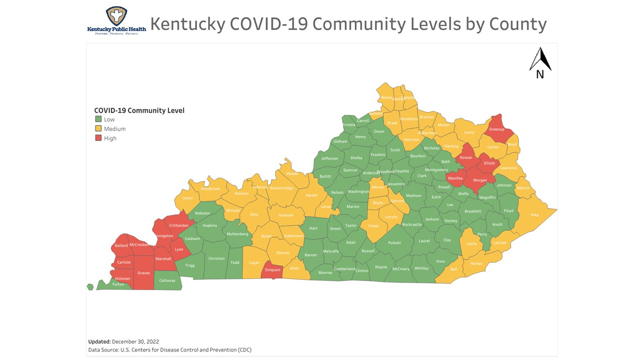
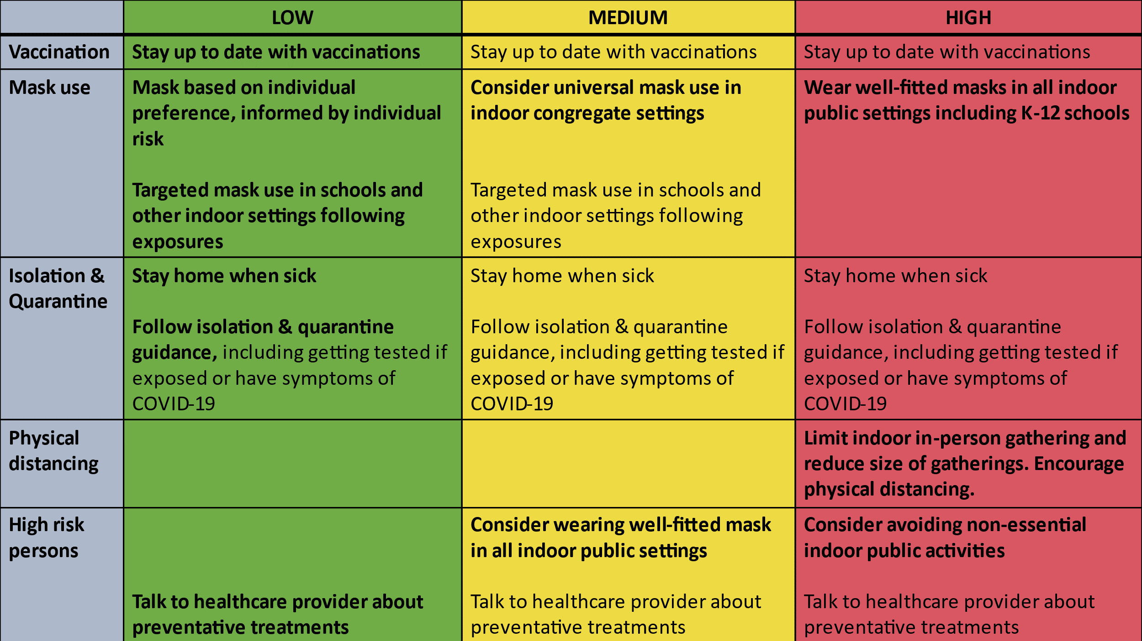

Here is the data for Marshall County as of today.
Total COVID Cases 10,351 (Increase of 234)
Hospitalizations for the month 4 (Decrease of 5)
Total COVID related deaths 125 (Increase of 1)

 | Dec 2022 | Nov2022 | Oct 2022 | Sep 2022 | Aug 2022
Cases for the month | 234 | 244 | 101 | 201 | 248
COVID related Deaths | 1 | 0 | 0 | 3 | 4

