Monthly Update
For September 2022

From Public Health Director, Billy Pitts

This month’s update is relatively mild; the numbers are steadily decreasing month to month. We experienced 47 less positive COVID cases during September than we did in August. We did, however, experience a slight increase in COVID related deaths. After two long years, COVID is no longer the number one topic of the day. Trust me, I am very happy with that. I only ask that you please not forget it is still with us, and will be with us long term, and there are those who are still highly susceptible to it.
The CDC recently adjusted the recommendations for wearing a mask in all settings, leaving it up to each induvial based on their preference, medical conditions, exposures, and community spread. Marshall County is currently at a medium level. Much of the state is at a low level with 19 counties primarily in the east at a high level.
We are still tracking the spread of Monkeypox. Information is on the second page of the attached update.
As always, you can contact me anytime you have questions or concerns.

Billy Pitts, MHA, MHR
Public Health Director
Marshall County Health Department
Office 270-252-2700
Mobile 270-970-1957

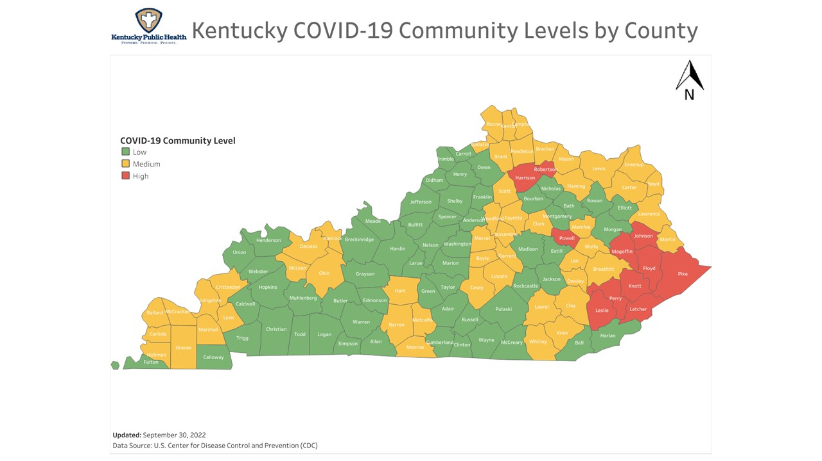
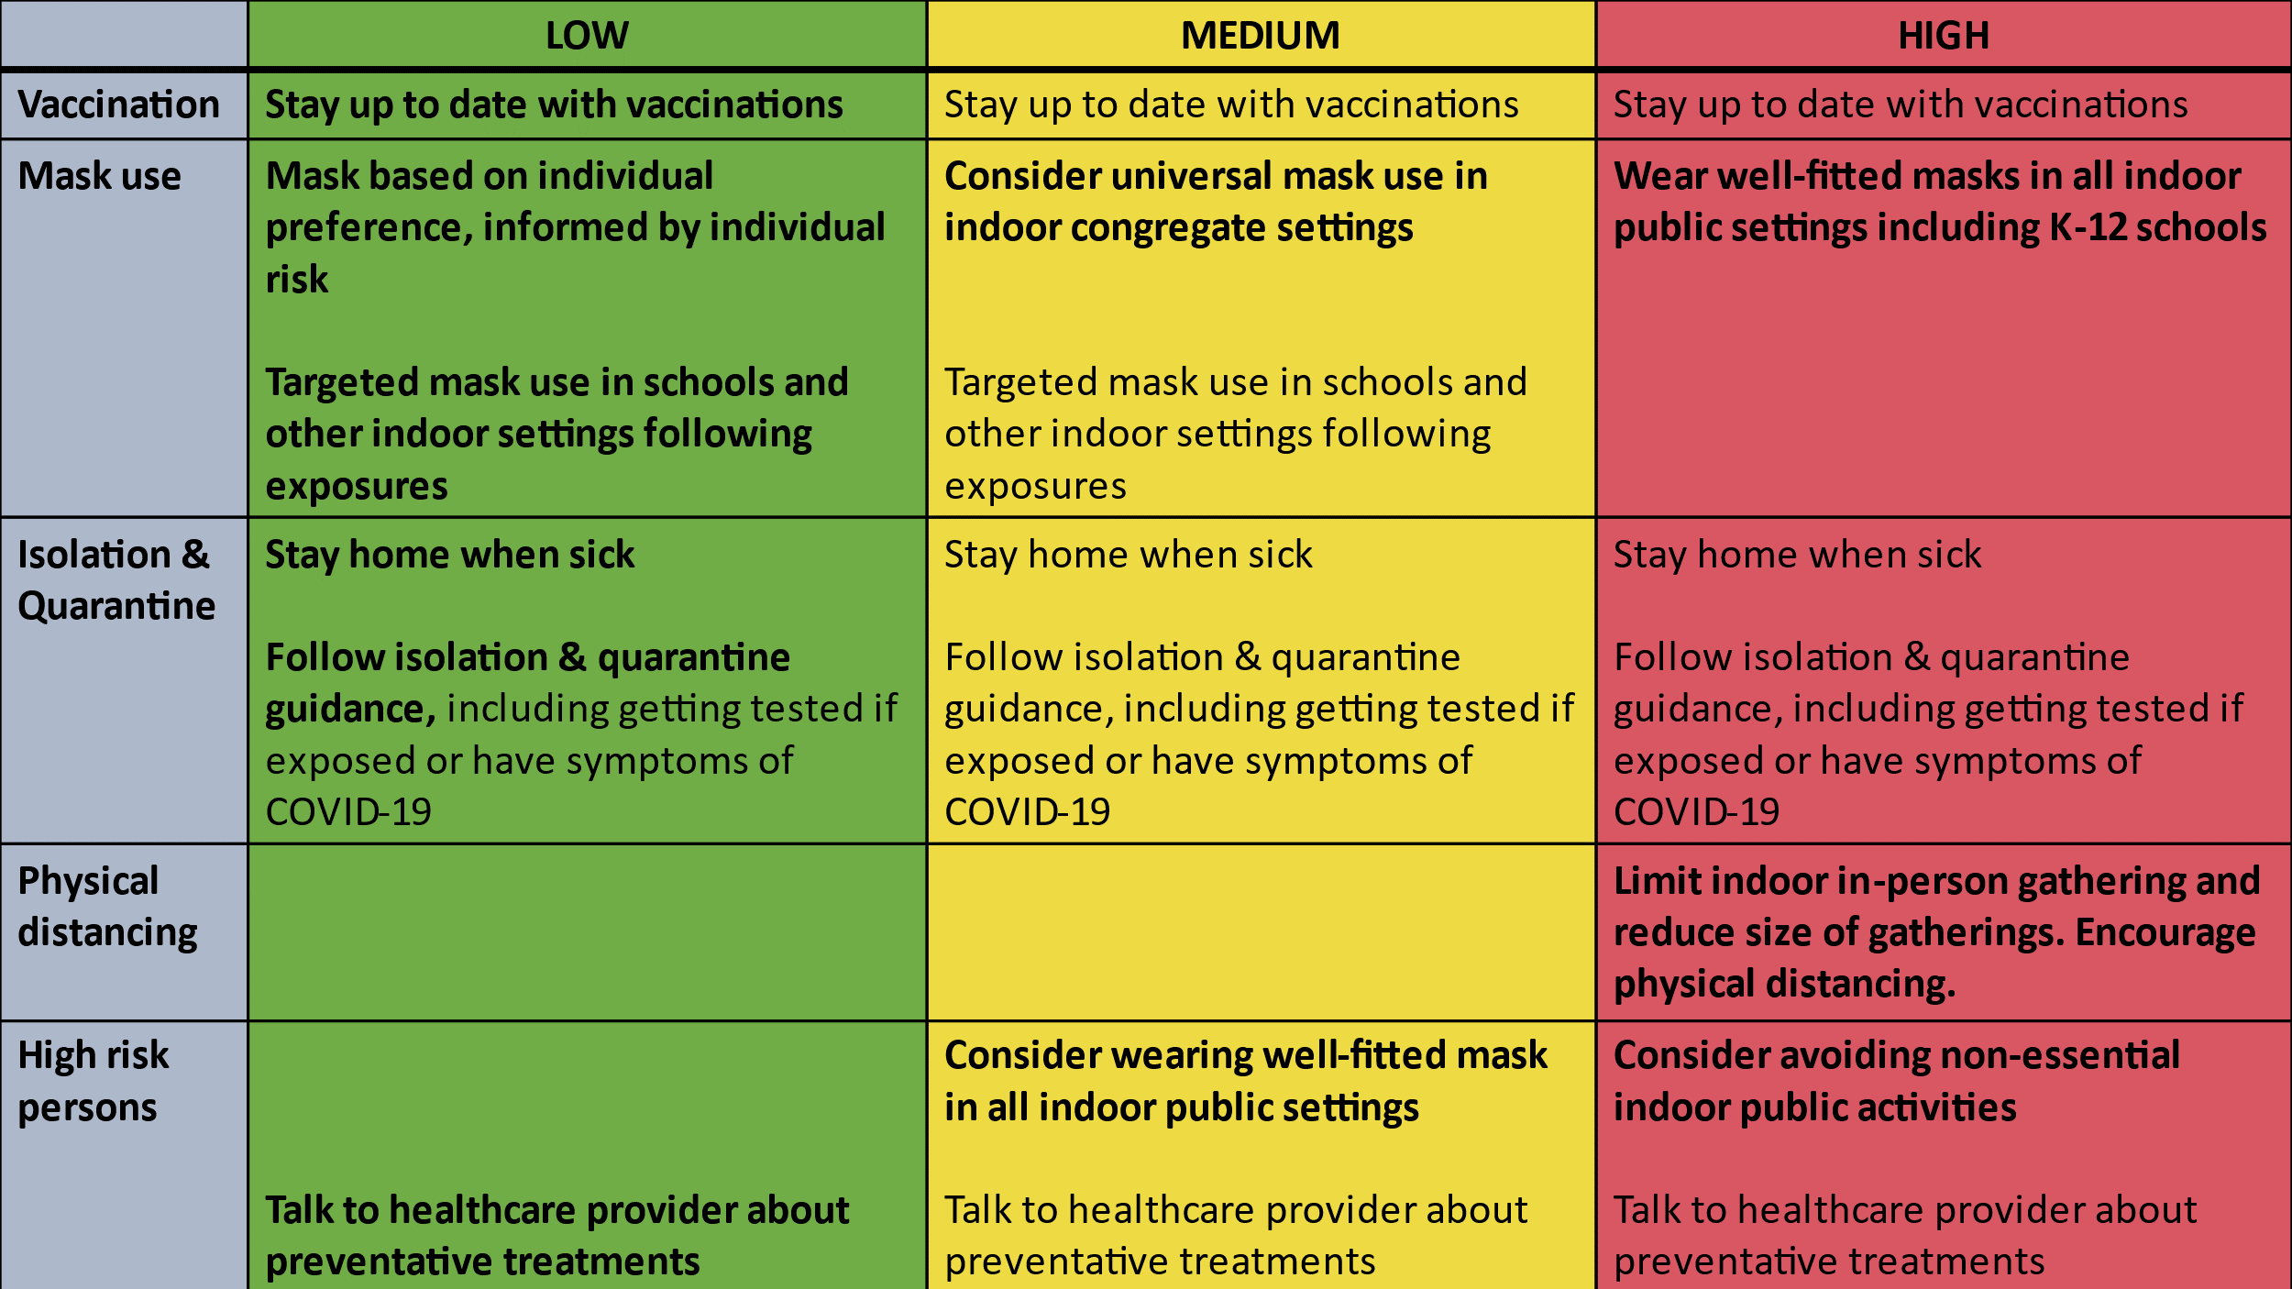

Here is the data for Marshall County as of today.
Total COVID Cases 9,772 (Increase of 201)
Current Active Cases 74 (Decrease of 14)
Hospitalizations in September 13 (Increase of 4)
Total COVID related deaths 124 (Increase of 3)

 | Sep 2022 | Aug 2022 | Jul 2022 | Jun 2022 | May 2022
Cases for the month | 201 | 248 | 293 | 312 | 118
COVID related Deaths | 3 | 4 | 2 | 1 | 10

See Monkeypox (MPX) on the next page
Monkeypox continues to spread although the rate appears to be slowing. Here are the latest confirmed numbers as of the date of this communication:
Worldwide 67,602
U.S. 25,613
KY 53
Purchase Region 1
More information about monkeypox, primary populations affected, how it is spread, availability of vaccine, who is eligible for vaccine, etc. can be found at the KDPH webpage (https://chfs.ky.gov/agencies/dph/dehp/idb/Pages/monkeypox.aspx). This link is also available on our webpage at marshallcohealthdepartment.com.
Disclaimer: All information in this update is point-in-time data. Information changes daily.

