Monthly Update
For August 2022

Good Morning and Happy September Everyone,

I am attaching the August update for Marshall County. There is much happening in the world today, so this month’s update contains a little more information than previous reports. The number of positive cases for COVID slightly dropped again for August with a total of 248 compared to 293 in July and 312 in June. This is a good trend. Please note, however, that the number of positive cases for school-aged children doubled from 21 in July to 42 in August. On a positive note, Marshall has once again entered the medium/yellow zone for transmission levels. Marshall has been in the red zone for the past several weeks.

I also included in the attached report information about the FDA approval of the bivalent booster. The biggest thing to note about this news is that the bivalent booster is the only booster now authorized for individuals 12 years of age and older; the monovalent boosters are no longer authorized for this group.

I also included information and a link to the KDPH webpage about monkeypox. As this virus continues to spread across the U.S. it is important for everyone to know as much as possible about it. The populations most affected by this virus are men who have sex with men, and most prevalent in the urban areas. Vaccine is available, however, it is in limited supply. For more information about monkeypox, what to look for, how it is spread, etc., click on the link provided in the attached update.

As always, feel free to contact me with any questions you may have.

Billy Pitts, MHA, MHR
Public Health Director
Marshall County Health Department
Office 270-252-2700
Mobile 270-970-1957

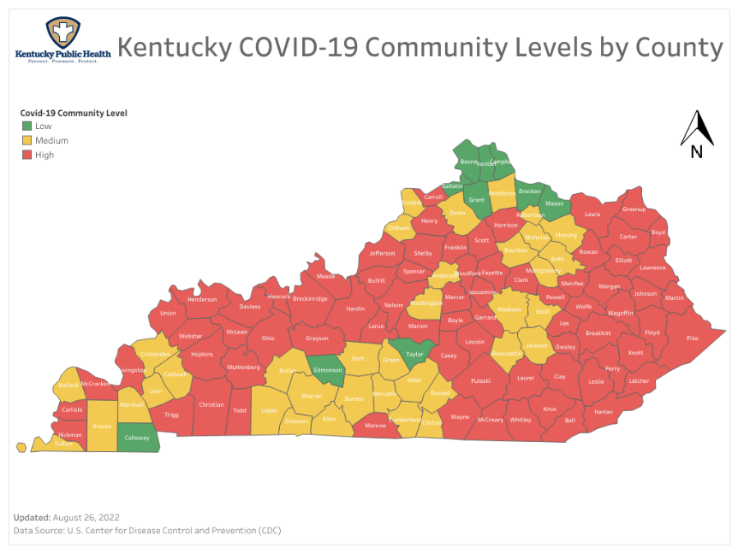
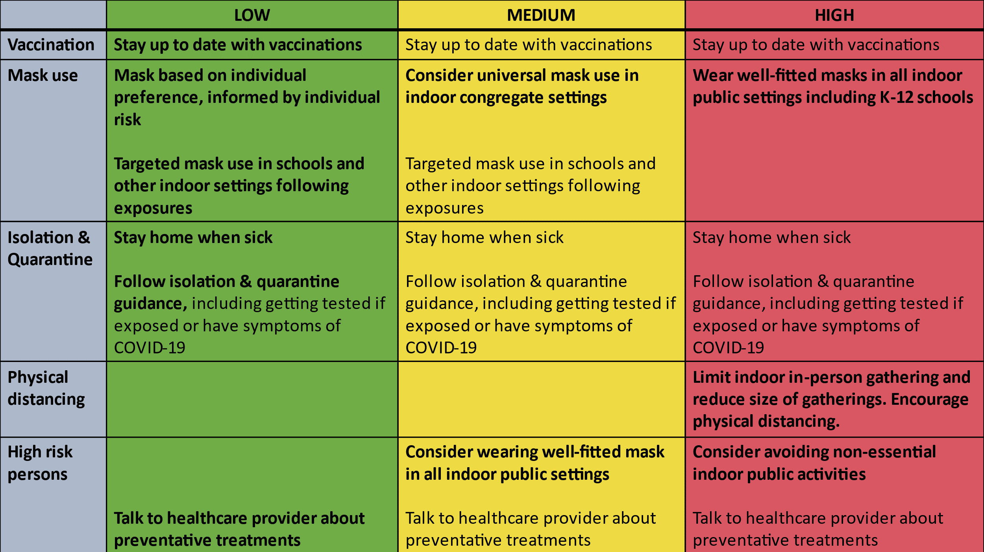

Here is the data for Marshall County as of today.

Total COVID Cases 9,571 (Increase of 248)
Current Active Cases 88 (Increase of 3)
Hospitalizations in August 9 (Decrease of 1)
Total COVID related deaths 121 (Increase of 4)

 | Aug 2022 | Jul 2022 | Jun 2022 | May 2022 | Apr 2022
Cases for the month | 248 | 293 | 312 | 118 | 18
COVID related Deaths | 4 | 2 | 1 | 10 | 4

42 of the COVID cases for August were school-age children; double the number of school-age children in July.
As of 8/31/2022 Moderna and Pfizer bivalent boosters were authorized by the FDA for individuals 12 years of age and older. At the same time, monovalent mRNA COVID vaccines are no longer authorized for booster in individuals 12 years of age and older. We will notify the public when we have the bivalent vaccine available at the Marshall County Health Department.
New guidance regarding isolation and quarantine was released in early August. That information is also available on our webpage and attached with this message.
Monkeypox is spreading across the United States. There are nearly 19,000 confirmed cases in the U.S. with 31 confirmed cases in Kentucky. More information about monkeypox, primary populations affected, how it is spread, availability of vaccine, who is eligible for vaccine, etc. can be found at the KDPH webpage (https://chfs.ky.gov/agencies/dph/dehp/idb/Pages/monkeypox.aspx). This link is also available on our webpage at marshallcohealthdepartment.com.
Disclaimer: All information in this update is point-in-time data. Information changes daily.

