Monthly Update
July 2022

From Public Health Director, Billy Pitts

We had a steady increase in cases from May to June, however, things stabilized for Marshall in July with 293 cases compared to 312 in June. Although a single death due to COVID is too many, two deaths in July compared to previous months is relatively low. All counties in Kentucky are in the medium to high risk level for transmission.

Billy Pitts, MHA, MHR
Public Health Director
Marshall County Health Department
Office 270-252-2700
Mobile 270-970-1957

Monthly Update
July 2022
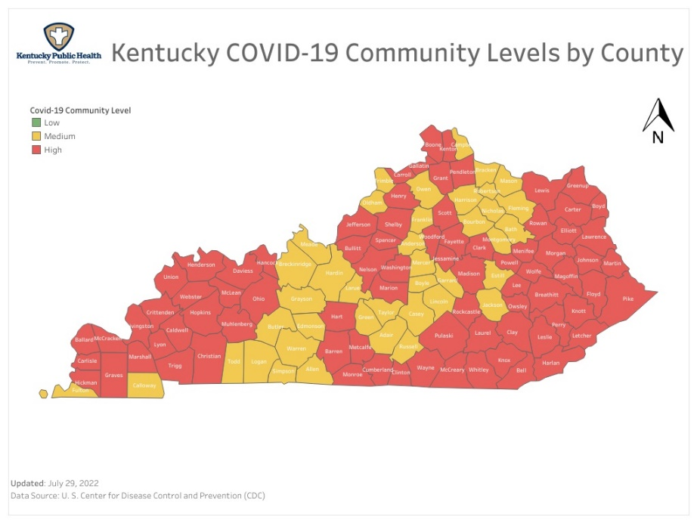
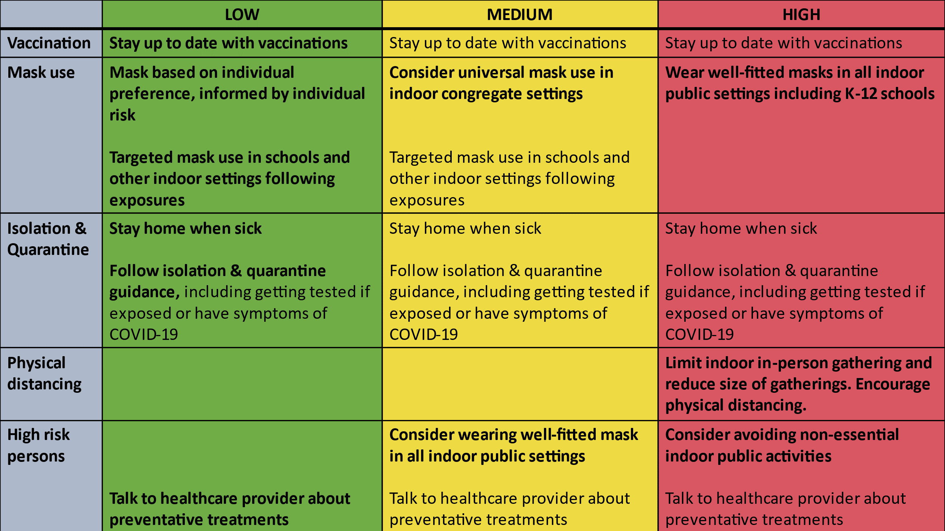

Here is the data for Marshall County as of today.

Total COVID Cases 9,323 (Increase of 293)
Current Active Cases 85 (Decrease of 1)
Hospitalizations in June 10 (Increase of 1)
Total COVID related deaths 117 (Increase of 2)

 | Jul 2022 | Jun 2022 | May 2022 | Apr 2022 | Mar 2022
Cases for the month | 293 | 312 | 118 | 18 | 51
COVID related Deaths | 2 | 1 | 10 | 4 | 6
Disclaimer: All information in this update is point-in-time data. Information changes daily.

