The numbers are looking great! The entire state is in the green minus a few rogue counties. We had only 18 new cases in April and only 7 of them currently active.

Let me know if you have any questions.

Billy Pitts, MHA, MHR
Public Health Director
Marshall County Health Department
Office 270-252-2700
Mobile 270-970-1957

Monthly Update
April 28, 2022
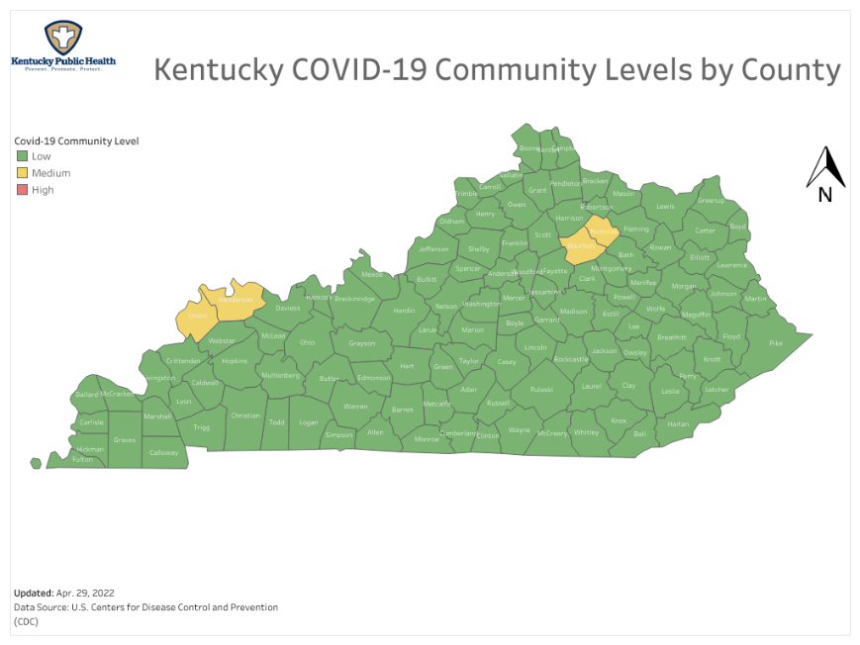
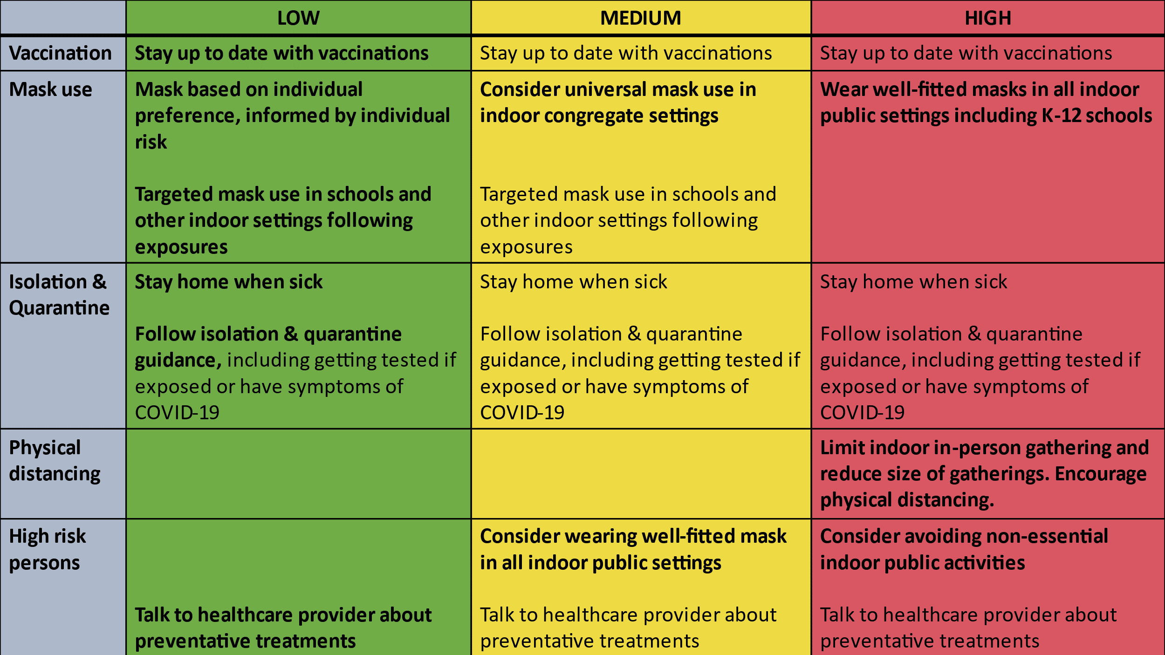

Here is the data for Marshall County as of today.

Total COVID Cases 8,598 (Increase of 18 from 3/31/22)
Current Active Cases 7 (Decrease of 5 from 3/31/22)
Current Hospitalizations 2 (Increase of 2 from 3/31/22)
Total COVID related deaths 104 (Increase of 3 from 3/31/22)

 | Apr, 2022 | Mar 2022 | Feb 2022 | Jan 2022 | Dec 2021
Cases for the month | 18 | 648 | 648 | 2,223 | 432
COVID related Deaths | 4 | 6 | 6 | 5 | 2

Disclaimer: All information in this update is point-in-time data. Information changes daily.
Billy Pitts, Marshall County Public Health Director.

